**NSSA-220 Project 1: Application Performance Monitoring**

**Tyler Padrao, Alex Sanchez, Evan Mikulski**

**Introduction**

For this project, our job was to write a script which would spawn all applications/processes, measure/monitor system and process level performance, and collect those metrics/data. We would then run it for 15 minutes, collecting metrics every 5 seconds and then create a report to display the metrics using excel plots, and in the end kill all application processes in the end in an exit trap function, “cleanup”.

**Process Level Metrics**

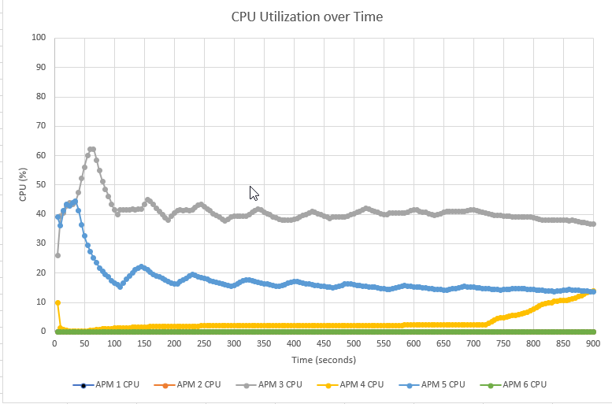

*Describe what the CPU utilization plot shows in 2-3 sentences.*

In general, APM3 and APM5 started with a high CPU usage, because of the application startup. After the application startup, the CPU usage went down about 20%. APM1, APM2, and APM3 didn’t have any CPU usage while APM4 mostly had a linear CPU usage over the span of 15 minutes.

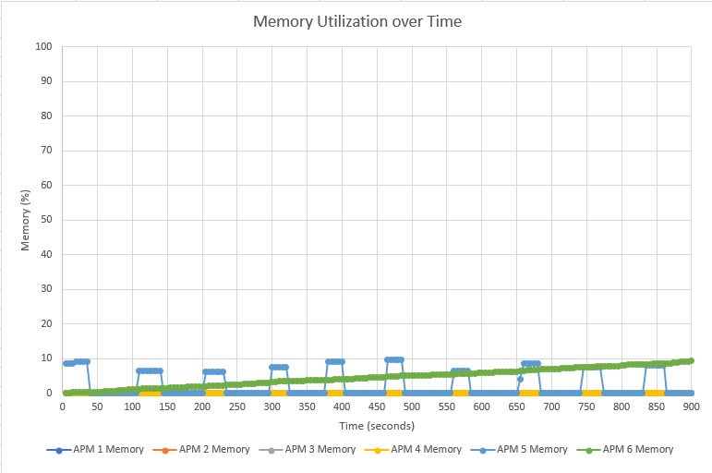

*Describe what the memory utilization plot shows in 2-3 sentences.*

APM1, APM2, APM3, and APM4 didn't have any memory usage. These applications must have not been performing any tasks within the 15 minute span. APM5 and APM6 had tasks running within the application. APM6 had a linear relationship usage of memory while this could signify a memory leak while APM5 kept having spikes in memory usage meaning a possible corrupted or malfunctioning driver.

**Potential things to write about**: Which processes used the most CPU/memory? Which processes used the least CPU/memory? Did any processes have any interesting patterns in their CPU and/or memory utilization? Could you see a memory leak (memory use that only increased over time) in any of the processes?

**System Level Metrics**

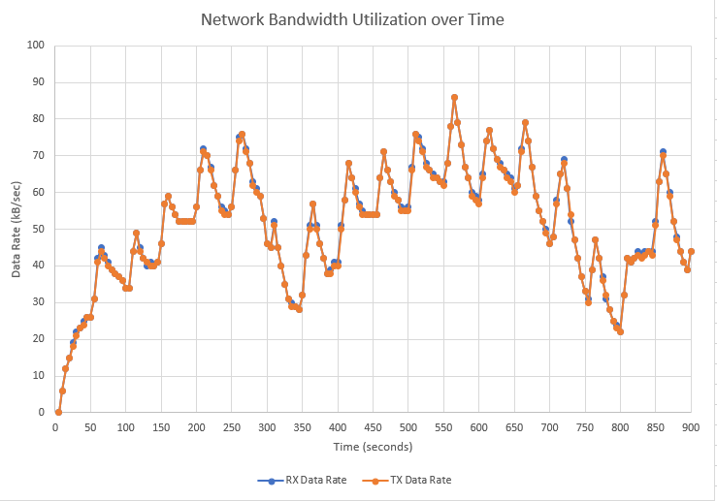

In this plot we are seeing the data being sent and received by the network card. What this graph is showing is that the TX and RX Rates are identical. This shows that whatever data is going out is coming right back at an equal amount. Taking into account that we are on a Gigabit link, We are well within capacity.

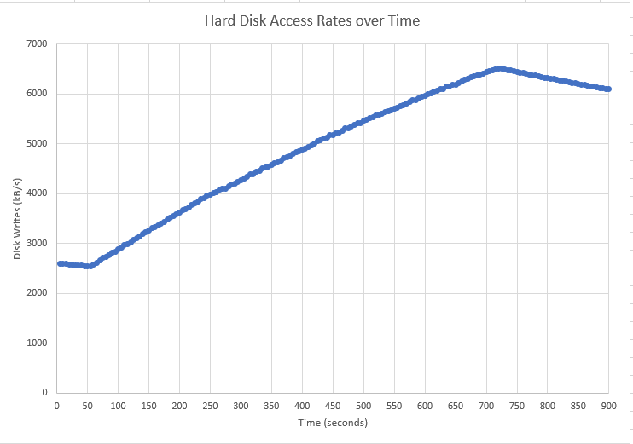

Through this graph we see that as time goes on, the system is increasingly using the disk as time goes on. This can be indicative of some kind of program that interacts with the disks often. Whether or not these numbers are of concern come down to the hardware installed on the system.

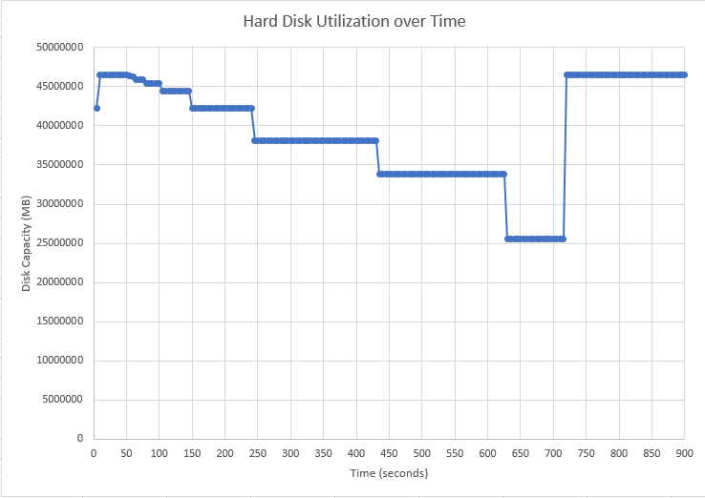

From this graph we see that the amount of available disk space decreases and at the end of execution we can infer that the files that were created by the programs get deleted. The available disk space at the dip is nowhere near cause for concern to get new disks.

**Potential things to write about**: How similar (or not) were the transmit and receive data rates? Could you see any patterns in how the data rates changed over time? Were there any interesting patterns in the hard disk access rates or hard disk utilization?

**Summary and Lessons Learned**

*Write 3-4 sentences that describe whether or not the VM you used had enough computing resources (CPU, memory, network capacity, and disk) to handle the mix of application processes that were running and what lessons you learned while working as a team on this project.*

The VM had enough CPU resources to run all 6 applications simultaneously. Although there was enough CPU resources, there was a point where 100% of the CPU was being utilized. There was a max of about 30% memory being utilized which the VM can handle fine. As for networking, we are well within capacity for the tasks being handled. While working as a team, our team worked together very well, along with all being coordinated, and we all were very reliable as we planned meetings. We have learned that teamwork builds good communication and collaborative skills.